Subjects were undergraduate students at East Carolina University who were enrolled in Dr. Karl Wuensch’s comparative psychobiology class (n = 200). Half of the students were taught a novel studying technique (n = 100), and half were taught to knit (n = 100). Each student was instructed to log of how many hours they spent either studying for the class, or knitting (TIME). Each student completed a standardized final examination in comparative psychobiology, resulting in a score (EXAM). **Based on their score on the Idealism subscale of the EPQ, subjects were classified as being idealistic or not idealistic.**

**A Potthoff analysis (simultaneous test of slope of intercept) was conducted to determine whether the slopes and intercepts for predicting AR from misanthropy differed between the groups. The analysis revealed that the regression lines for the two groups were not coincident, *F*(2, 150) = 3.623, *p* = .029. Follow-up analyses revealed that the two groups did differ significantly in slopes, *t*(150) = 2.25, *p* = .026, as well as in intercepts, *t*(150) = 2.58, *p* = .011. As shown in Figure 1, the slope was significantly higher in the group of nonidealists, and the intercept was significantly higher in the group of idealists.**

**Within the nonidealistic group, AR was significantly related to misanthropy, , *t*(89) = 3.69, *p* <.001, *r* = .364, 95%CI [.171, .530]. Within the idealistic group, AR was not significantly related to misanthropy, , *t*(61) = 0.16, *p* = .87, *r* = .02, 95% CI [-.228, .338].**

Figure 1. Predicting Exam scores from Tim devoted to study in Control and Experimental group  
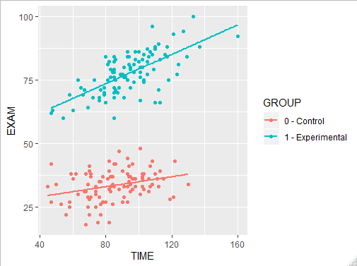

1. Conduct test of coincidence

• If the test of coincidence is significant, report the tests of slopes and the test of intercepts.  If you are using SAS, these will be available in the GLM output used to test coincidence.

• If the test of slopes is significant, probe the interaction by testing the simple effects of time by group.  Process Hayes will give you these.

• Test the unconditional effects.  Do the groups differ on exam performance (independent samples *t* test).  Is the zero-order correlation between study time and exam performance significant?

If you take the approach Hayes prefers, replace the description of the within-group regressions with something like this:  As shown in Figure 1, the slope (.30) for predicting attitude from misanthropy was significant in the nonidealistic group, 95% CI [.14, .46], but not in the idealistic group (.02), 95% CI [-.18, .21].

Tips:

If the test of coincidence is not significant, then don’t report the test of slopes or the test of intercepts.  Coincident lines have identical slopes and intercepts.If the test of coincidence is not significant or, even if it is, if the test of slopes is not significant, drop the interaction from the model and conduct an ANCOV.